Deliverable Di.9.1.:
Standard operating procedure for the detection of cholestasis-inducing agents in cultured primary rat hepatocytes

Workpackage: WP9

Workpackage leader: P5

Lead contractor of this deliverable: P5

Table of contents

- Introduction 3
- Purpose 3
- Scope and limitations 3
- Method outline 4
- Consumables and equipment 4
  - Products and reagents 4
  - Materials and devices 4
- Methods 5
  - Biliary excretion study 5
  - Processing of the results 5
- Health safety and environment 6
- Notes 6
- References 6

Abbreviations

Bsep bile salt export pump
CLF cholyl-lysyl-fluorescein
DILI drug-induced liver injury
DMSO dimethylsulfoxide
HBSS Hank’s balanced salt solution
Ntcp Sodium-dependent taurocholate cotransporting polypeptide
- Introduction

Drug-induced liver injury (DILI) is of major concern to the pharmaceutical industry, since it underlies the withdrawal of a considerable number of drugs during drug development (Schuster et al., 2005; Kaplowitz, 2004). DILI can be clinically manifested in a number of acute and chronic conditions, including cholestasis. Basically, cholestatic insults results from dysregulation of normal bile formation. At the molecular level, cholestasis can be caused by a multitude of mechanisms, among which the inhibition of the bile salt export pump (Bsep) (Dawson et al., 2012; Padda et al., 2011). Bsep is a membrane protein that is expressed at the canalicular membrane pole of human and rodent hepatocytes and which conveys bile acids and salts from the cytosol into the bile canaliculi. Suppression of Bsep transporter activity has been reported for a plethora of cholestasis-inducing drugs, including cyclosporine A (Kis et al., 2011). Hence, measurement of Bsep inhibition by candidate drugs can be considered as a read-out for testing the cholestasis-inducing potential of chemical compounds.

- Purpose

The present standard operating procedure describes a method to assess the cholestasis-inducing potential of chemicals, in casu in cultures of primary rat hepatocytes. The procedure relies on the accumulation of the fluorescent Bsep substrate cholyl-lysyl-fluorescein (CLF) in the canalicular network of sandwich-cultured rat hepatocytes either in the presence or the absence of Bsep inhibitors.

- Scope and limitations

The current protocol comprises an easy-to-apply method to detect cholestasis-inducing agents based on Bsep inhibition. Since sandwich cultures of hepatocytes, in contrast to conventional monolayer cultures, exhibit reformation of the canalicular network and polarized excretory functions, this culture system forms an appropriate experimental setting for studying biliary excretion (Swift et al., 2010). The set-up of sandwich cultures of primary hepatocytes, in casu from rat, has been described in detail previously (Vinken et al., 2006) and is beyond the scope of the current document.
Most Bsep substrates, including CLF, cannot undergo efficient cellular translocation without the support of an uptake transporter, such as sodium-dependent taurocholate cotransporting polypeptide (Ntcp). A number of drugs, known to inhibit Bsep activity, also possess the ability to interfere with the Ntcp-mediated uptake of bile salts. This phenomenon should always be taken into account as it may complicate the interpretation of the experimental results (Swift et al., 2010).

- Method outline

Basically, the standard operating procedure outlined in this document consists of 2 steps, namely (i) the detection of Bsep inhibition by fluorescence microscopy and (ii) the processing of the results. Practical details are provided for each of these 2 steps and are followed by some useful tips based upon our own hands-on experience.

- Consumables and equipment
  - Products and reagents
- Hank’s Balanced Salt Solution (HBSS), Calcium, Magnesium, no phenol red (14025-050, Life Technologies, Belgium)
- Cyclosporine A (C1832, Sigma, Belgium):
Preparation of stock solution: 200 µM cyclosporine A
Cyclosporine A 5 mg
Dimethylsulfoxide (DMSO) 20.97 ml
→ This solution can be stored at -20º C.

- CLF (451041, BD Bioscience, Belgium):
Preparation of stock solution: 5 mM CLF
CLF 1 mg
DMSO 125 µl
→ This solution can be stored at -20º C.

Preparation of substrate work solution: 5 µM CLF
5 mM CLF stock solution 1 µl
HBSS 1 ml
→ This solution must be prepared ex tempore and stored protected from light.

Preparation of inhibition work solution: 5 µM CLF + 1 µM cyclosporine A
5 mM CLF stock solution 1 µl
200 µM cyclosporine A stock solution 5 µl
HBSS 1 ml
→ This solution must be prepared ex tempore and stored protected from light.

  - Materials and devices
- Automatic pipets and tips (10 µl, 100 µl, 1000 µl, Eppendorf-VWR, Belgium)
- Centrifuge tubes (15 ml, CellSTAR®, Greiner bio-one, Belgium)
- Freezer (-20°C, Bauknecht GKMC3611, VWR, Belgium)
- General glassware (VEL, Belgium)
- Microcentrifuge tubes (1.5 ml and 2 ml, Eppendorf 0030-120094, VWR, Belgium)
- Parafilm (Parafilm M, American National Can, VWR, Belgium)
- Pasteur pipets (Bilbate, United Kingdom)
- 6 well-plates (uncoated, diameter 35 mm, BD FalconTM, BD Biosciences, Belgium)
- Pipettor (Pipetus, Flow Laboratories, Belgium)
- Thermostated bath (37°C, Grant W14, VEL, Belgium)
- Volumetric pipets (Greiner Bio-one, Belgium)
- Vortex (L46 Labinco, VWR, Belgium)
- Fluorescent microscope (Nikon Eclipse Ti-S, Belgium)

- Methods

  - Biliary excretion study

- Warm HBSS at 37°C before use (see note 1). Prepare all work solutions as instructed (see note 2).
- Aspirate the culture medium carefully from sandwich-cultured hepatocytes and rinse the cells 3 times with 2 ml HBSS.
- Add 2 ml HBSS to each well and place the 6-well plates in an incubator at 37°C for 10 minutes.
- Remove HBSS from the cells, incubate the half of a 6-well plate with 1 ml substrate work solution or inhibition work solution and place the 6-well plates in an incubator at 37°C for 20 minutes.
- Aspirate the work solutions carefully from the sandwich-cultured hepatocytes, rinse the cells 3 times with 2 ml HBSS and finally add 2 ml HBSS to each well.
- Analyse the 6-well plates by light and fluorescence microscopy (see note 3).

  - Processing of the results

- Take a fluorescent and phase-contrast image of the cell culture.
- Superpose both images and study the accumulation of CLF in the bile canaliculi (Figure 1) (see notes 4 and 5).
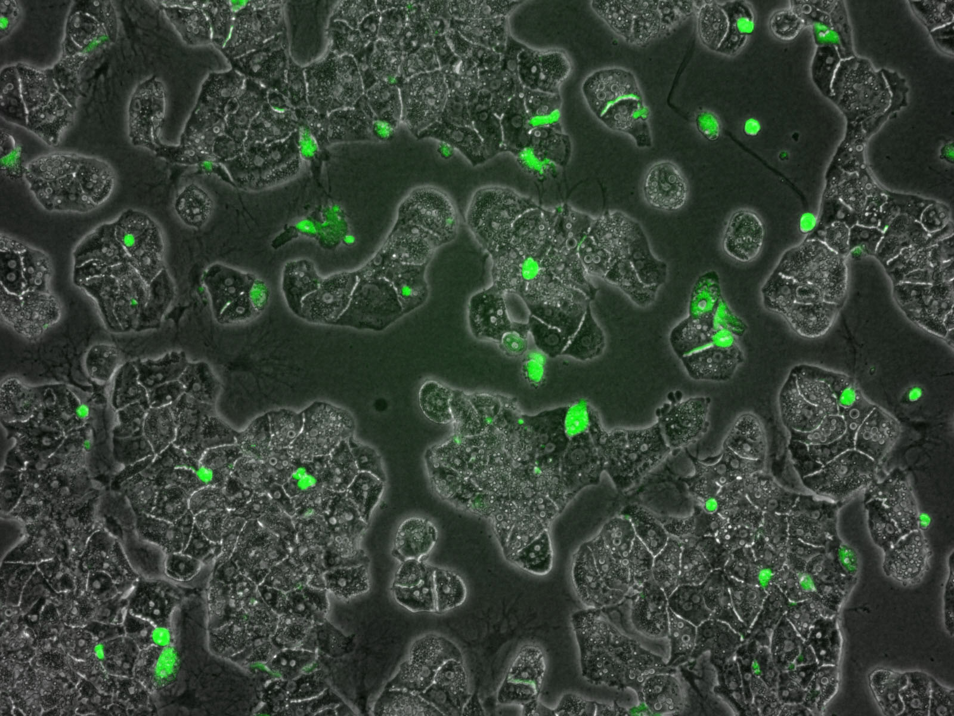
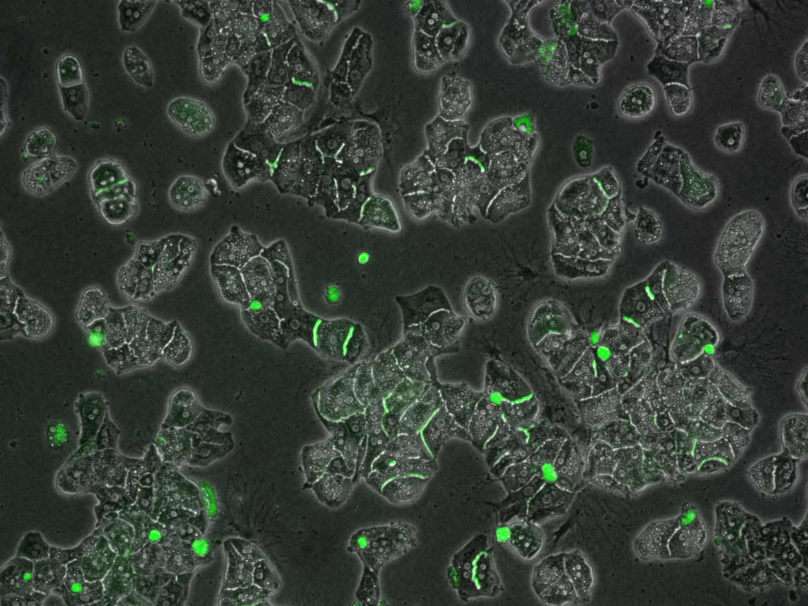
Sandwich-cultured rat hepatocytes incubated with 5 µM CLF
Sandwich-cultured rat hepatocytes incubated with 5 µM CLF + 1 µM cyclosporine A

Figure 1: Accumulation of CLF in the bile canaliculi of sandwich-cultured rat hepatocytes in the presence or absence of the Bsep inhibitor cyclosporine A.
- Health safety and environment

Caution should be taken when handling cyclosporine A due to its carcinogenic properties. All operations should be executed in a laminar air flow cabinet. Gloves and a laboratory coat must be worn by the operators when performing all procedures. All the materials utilized for cell cultures must be discarded according to appropriate procedures for special biological waste. As also holds for other laboratory reagents, contact between the work solutions, skin and mucous membranes must be avoided.

- Notes

- Temperature is a critical parameter in this assay, as it influences the activity of the transporters. All tests should be conducted at 37°C to ensure physiologically relevant transporter activity.
- Each experimental condition should be tested in triplicate.
- CLF (λ_{EX} = 486 nm; λ_{EM} = 520 nm) is a green fluorescent.
- The accumulation of CLF in the bile canaliculi of sandwich-cultured hepatocytes will be generally less pronounced in the prescence of a Bsep inhibitor, such as cyclosporine A.
- Quantification of CLF accumulation is possible using specific software applications allowing the measurement of fluorescence intensity, such as Image J.

- References

Dawson, S., Stahl, S., Paul, N., Barber, J. & Kenna, J. G. 2012. In vitro inhibition of the bile salt export pump correlates with risk of cholestatic drug-induced liver injury in humans. Drug Metab Dispos, 40, 130-8.
Kaplowtiz, N. 2004. Drug-induced liver injury. Clin Infect Dis, 38 Suppl 2, S44-8.
Kis, E., Ioja, E., Rajnai, Z., Jani, M., Méhn, D., Herédi-Szabό, K. & Krajcsi, P. 2011. BSEP inhibition - In vitro screens to assess cholestatic potential of drugs. Toxicol In Vitro.
Padda, M. S., Sanchez, M., Akhtar, A. J. & Boyer, J. L. 2011. Drug-induced cholestasis. Hepatology, 53, 1377-87.
Schuster, D., Laggner, C. & Langer, T. 2005. Why drugs fail - A study on side effects in new chemical entities. Current Pharmaceutical Design, 11, 3545-59.
Swift, B., Pfeifer, N. D. & Brouwer, K. L. 2010. Sandwich-cultured hepatocytes: an in vitro model to evaluate hepatobiliary transporter-based drug interactions and hepatotoxicity. Drug Metab Rev, 42, 446-71.
Vinken, M., Elaut, G., Henkens, T., Papeleu, P., Snykers, S., Vanhaecke, T. & Rogiers, V. 2006. Rat hepatocyte cultures: collagen gel sandwich and immobilization cultures. Methods Mol Biol, 320, 247-54.

