# Cerebellar brain slice protocol

**1. Culture medium**

|  |  |  |
| --- | --- | --- |
| Minimal essential media (MEM) (Gibco) | 50 % | 25 mL |
| **EBSS (Gibco)** | 25 % | 12.5 mL |
| **Heat inactivated horse serum** | 25 % | 12.5 mL |
| **Penicillin/Streptomycin** | 1 % | 0.5 ml |
| **GlutaMax (200 nM)** | 1 % | 0.5 mL |
| **Glucose 100g/L (Sigma)** | 6.5 mg/ml | 3.3 mL |
|  |  |  |
| **Total mL** |  | **50** |

**2. Dissection medium**

PBS/glucose 0.1% final: Prepare 3.6 mL of 100g/L Glucose (filtered, first dissolve 3,6 ml in 25 ml PBS) in 200 mL of PBS 1x (4°C)

**3. Millicel well plate**

* Prepare Millicel well plate (24 well plate)
  + Put 250 µl culture medium in well
  + Add a Millicel to each medium containing well (Day before dissection or in morning)

**4. Dissection 🡪 P9-P10**

* Cut off the mouse head
* Put some ethanol over the head before starting the dissection
* Pinch the mouse nose with the curved pincers and with the curved scissors remove the skin near the ears and pull gently
* With plate scissors gently enter from the foramen magnum and cut the cranium from the back to the front at eyes level.
* With pincers remove the skull (be careful not to damage the tissues!)
* Remove brain + cerebellum and put into a small Petri dish with dissection medium

Under the binocular with thin pincers:

* Separate cerebellum from brain: pinch brain with a pincers and use the other one to cut the tissue between cerebellum and the brain (*Note: brain cortex can be used simultaneously for primary cell isolation)*
* Separate cerebellum from brain stem: pinch just down the stem and with the help of the other pincers cut the cerebellum



* Try to remove meninges (lift gently with pincers where it is possible to see vessels)
* Install the razor blade: put Teflon plate on Chopper (previously washed in alcohol 100%) and then tighten the razor blade
* Put cerebellum on Teflon plate, perpendicular to the razor blade, aspirate the dissection medium surplus with the glass Pasteur pipette (Caution ! Check the position of the cerebellum before starting to cut and also the position of the metal clips on the chopper! they must remain perpendicular to the blade)
* Cut the cerebellum with chopper: 350 µm thick (ON + Reset)

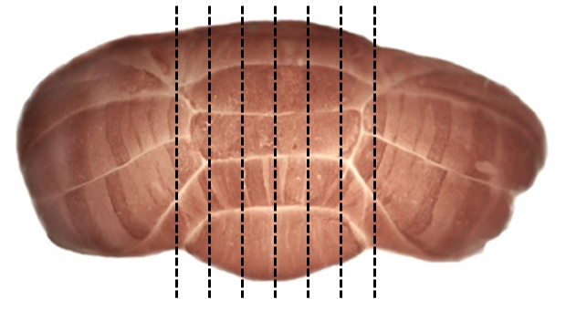

* Transfer the slices into a new small Petri dish with dissection medium using a glass Pasteur pipette: make the slices slide from the Teflon plate to the Petri dish
* Separate and select the slices of interest (vermis level) using syringes (5-6 slices)
* Take slices with the cut plastic Pasteur pipette and put them in the center of the Millicell (2-3 slices/well)

NOTE: Attention in placing the slices: don’t touch the edges of the Millicell or slices each others

* Aspirate and throw away the remaining dissection medium

**At the end of dissection CHANGE the culture medium, it must be warm (37 ° C): 250 µl/well**

**5. Brain slice culture – demyelination**

* Chance 150µl of the 250µl culture media each 2-3 days until 6 days after isolation (isolation = day 0)
* After 6 days: demyelinate the brain slices
  + Incubate the slices for 18hr in 0.5mg/ml lysolecithin
  + After 18hr: “wash” the slices by placing them 10 minutes in fresh culture media
  + After washing: let the slice recover until the next day (± 24 hours)
    - In the first 24 hours, inflammation processes are prominent and possibly not wanted to study regenerative processes
  + Treatment can be started for 2 weeks
* Brain slices are fixed in 4% PFA for 40 minutes (do not forget to include a demyelination control slice that is fixed after washing the slices for 10 min and before the recovery period)