Protocol
In vitro serum protein binding assay of small proteins

- Aim

Determine whether small proteins interact non-specifically with serum proteins in vitro in order to predict an unfavorable biodistribution in vivo.

- Materials

Item | Comment | Example
Small protein of interest | Fluorescently- or radioactively labeled
Serum | From human or animal origin, depending on the study | Merck
FPLC system | Equipped with detector measuring absorbance at 280 nm (serum proteins) and absorbance at maximal excitation wavelength of the fluorescent dye or detection of radioactive signals | FPLC: NGC Chromatography system, Biorad  Radioactive detector: Gabi detector, Elysia-Raytest
Size-exclusion chromatography column | With pore size adequate to separate small proteins from serum proteins | Superdex 75 Increase 10/300 GL, Cytiva
Running buffer | Compatible with serum proteins and compound of interest | PBS
Small lab consumables | Pipets, tips, vials, injection needles, syringes, 0.22 µm syringe filters

- Method

- Add 50 µL of fluorescently- or radiolabeled protein (concentration typically between 0.1 and 1 mg/mL) to 200 µl of serum.
- Incubate the sample at 37°C for a chosen period of time (15-60 min to assess serum protein binding.
- Filter the sample with a syringe filter
- Analyze the sample via size-exclusion chromatography. Serum proteins are detected via absorbance at 280 nm; the fluorescently- or radioactively labeled protein via absorbance at the maximal excitation wavelength of the fluorescent dye, or via its radioactive signal.
- Compare the retention time of the compound of interest after incubation with the serum proteins, with the reference retention time of the compound (i.e. when not incubated with serum proteins).
- If a significant left-shift of the fluorescent or radioactive signal, overlapping with the signal of the serum proteins is observed, it can be concluded that the compound of interest binds to serum proteins.

- Conclusions:

Serum protein binding can significantly affect the pharmacokinetics of small proteins. If this is not warranted for future applications, compounds that exhibit serum protein should not be further selected for in vivo assessment because this is associated with non-specific uptake, particularly in the liver.

- Example

In this example, we investigated the biodistribution of fluorescently-labeled Nanobodies (Nb) that could be used as tools to non-invasively visualize tumor biomarkers in vivo (e.g. for application in image-guided surgery). The Nbs were labeled with 3 different fluorescent dyes with different physicochemical properties (dye A, B, C).

The biodistribution profile of Nb-DyeA, -B and -C at 1 hour after intravenous injection is shown in Figure 1. For all compounds, signals in the kidneys and bladder are the most pronounced. As compared to Nb-DyeA and -DyeC, high background signals are observed for Nb-DyeB, both on ventral and dorsal surfaces. This leads to low tumor contrast for this tracer, unlike the other two tracers for which the tumor is clearly discernable from surrounding tissues. Moreover, the faint liver signal on the ventral images of Nb-DyeB implies partial hepatic metabolism. The results for Nb-DyeB are explained by the slow clearance from the circulation due to the binding of this tracer to serum proteins as confirmed in Figure 2. This also contributes to higher liver accumulation.

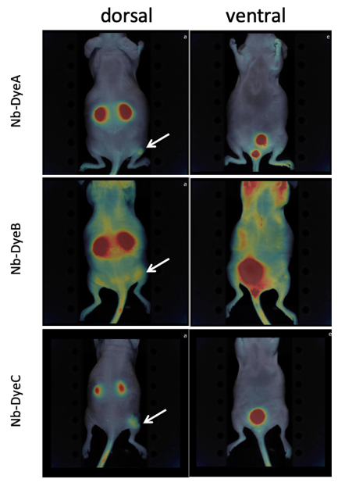
Figure 1: In vivo 2D fluorescent images of the ventral and dorsal side of mice, depicting the biodistribution profile of Nb-DyeA, -B and -C, 1h post-intravenous injection. Fluorescent signals are color-coded and overlayed on black- and white brightfield images of the animal’s anatomy. Subcutaneous tumors are indicated with a white arrow.

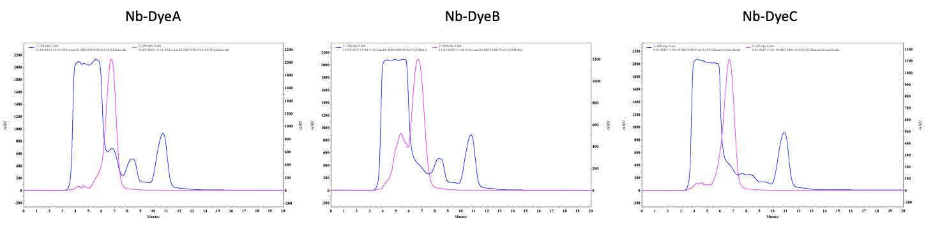
Figure 2: Size-exclusion chromatography profile of Nb-DyeA, -B and -C following incubation with serum proteins. Fluorescent signal is represented by the pink line, absorbance of the serum proteins at 280 nm is shown as a blue line. Nb-Dye A and -C elute as a single peak at the expected retention time. Contrarily, Nb-DyeB exhibits a partial left-shift, overlapping with the signal of the serum proteins.

